OPC UA (OPEN PLATFORM COMMUNICATIONS UNIFIDE ARCHITECTURE)

Terminology

1. OPC = OLE for Process Control = object linking and embedding for process control
2. OLE = object linking and embedding.
3. OPC = Classic OPC
4. OPC UA = Open Platform Communications Unified Architecture

INTRODUCTION:

OPC Unified Architecture (OPC UA) is the information exchange standard for secure, reliable, manufacturer- and platform-independent industrial communications. It enables data exchange between products from different manufacturers and across operating systems. The OPC UA standard is based on specifications that were developed in close cooperation between manufacturers, users, research institutes and consortia, in order to enable consistent information exchange in heterogeneous systems. For nearly three decades, OPC has been, and continues to be, the go to connectivity standard in industry. With the advent of the Internet of Things (IoT) era,OPC adoption has also shown growth in new, non-industrial markets. By introducing a Service-Oriented-Architecture (SOA) in industrial automation systems in 2007, OPC UA started to offer a scalable, platform-independent solution for interoperability which combines the benefits of web services and integrated security with a consistent data model.

If HMI/SCADA software did not exist, then there would be no need for classic OPC

Before classic OPC & OPC – UA:

Prior to the introduction of classic OPC and OPC-UA, unique drivers for various PLCs were required for connecting to HMI or SCADA software.

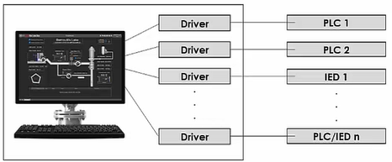

After classic OPC:

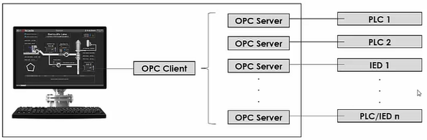

Limitation of Classic OPC:

* Dependence on Microsoft COM/DCOM Technology.
* Insufficient security
* Limited data organization.

OPC-UA technology came before us as a solution to the above-mentioned problems

After coming OPC-UA :

* Security implemented
* More structured data organization
* It not depends on microsoft operating system . it run on anything

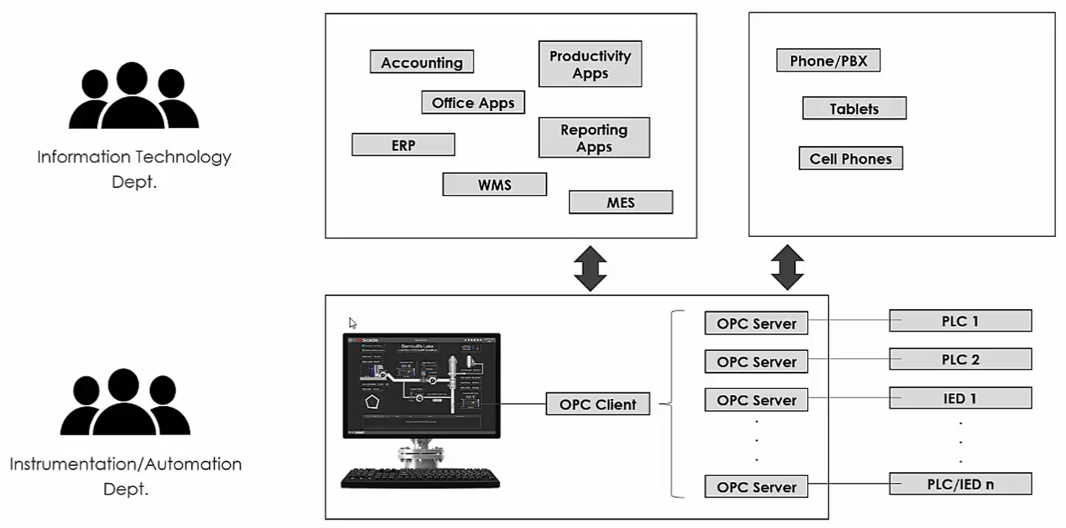

* Will OPC UA eventually replace other protocol like Modbus TCP , Profibus ,Profinet , Ethernet/IP,etc ?
* No. Absolutely not!

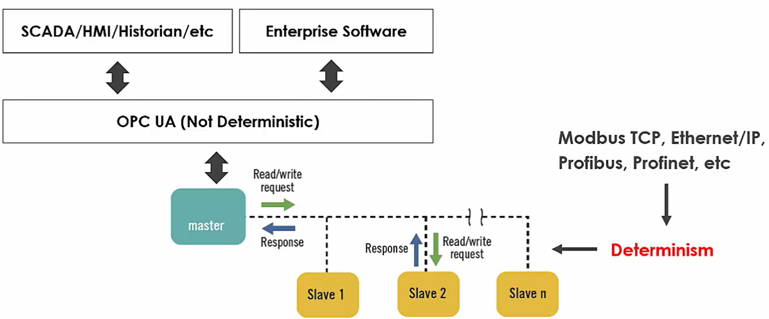

OPC UA – some specific security terminology

* Self – signed certificate
* Owned & trusted certificates
* Security mode
* None
* Sign
* Sign & Encrypt
* Security policy
* Algorithm used for signing and encryption
* Additional authentication
* Anonymous
* Username and password
* Certificate
* Issued token

